
Katie Hammerton
Digital Marketing – HoneyPot SEO
November 10, 2021

Target Keyword Phrase
To start the search, I used words like “baby” and “infant” to see what searches were popular. I then added in the word “swaddle” to start matching keywords to the website. The best search result I found was “baby sack”. Using a GEO for the entire U.S. since she sells nationally, the baby sack topic has gone up in trend by 107% with a total search volume of 210, an average CPC of $2.97, and an average competition of 96 (High). These numbers don’t come from “baby sack” specifically, but the top keyword phrases using baby sack. However, seeing as how the phrase is trending it is reasonable to assume that the keyword itself would perform exceedingly well.

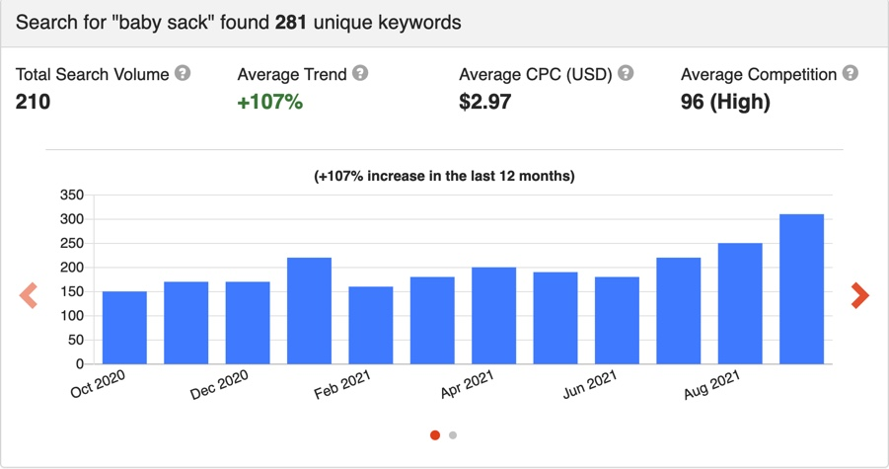

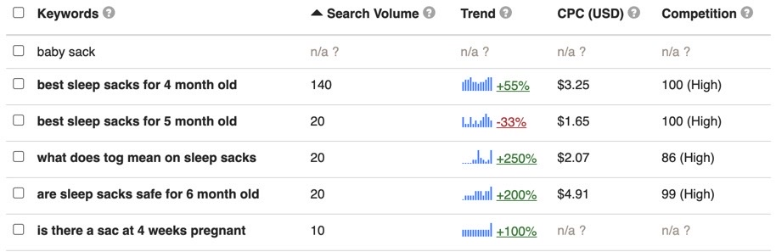

The current URL of the page is https://swaddelini.com/shop/ , and I believe it should be https://swaddelini.com/shop/baby-sack-products/. Adding the keyword allows for extra weight when relevance is calculated, so consumers are more likely to see the shop page when they search for baby sacks or information about baby sacks.

Title Tag
The current title tag is ‘Products-Swaddelini’. It is my recommendation that it become ‘Shop Baby Sack Products | Swaddelini’. Keeping the words ‘shop’ and ‘products’ allows for consumers to know it is a transactional page, while ‘baby sack’ gives it keyword targeting and specification for consumer ease. It is under the 67 character limit while also being optimized.

Header Tags
There is no Header 1 tag. The ‘Shop’ title is labeled “page-header_title” when using the inspect feature on Google. The title should be changed to <h1> and it should be replaced with ‘Shop Baby Sack Products’. This way, the target keyword phrase is in the <h1> title while keeping the page name and purpose clear. The Header 2 titles are the product names: Boo-Boo Blue, Orange you glad I’m cute?, Graceful Gray, Peaceful Pink, Bamboo Breast Cancer Pink, Bamboo Millennial Mint, Raindrop, Light Swaddelini, and The Adult Swaddelini. It is my recommendation that the product names are changed to add ‘Baby Sack’ to the end of each product name, except for The Adult Swaddelini. This adds the keyword phrase to the product names and relevance weight for the website. The widgets featuring ‘Filter By Price’, ‘Bestsellers’, and ‘Shopping Cart’ do not have header tags, they are either called a widget title or product title. If possible, I believe these should become Header 3 tags. This adds weight for the website, and they don’t need the keyword added to them to do it.

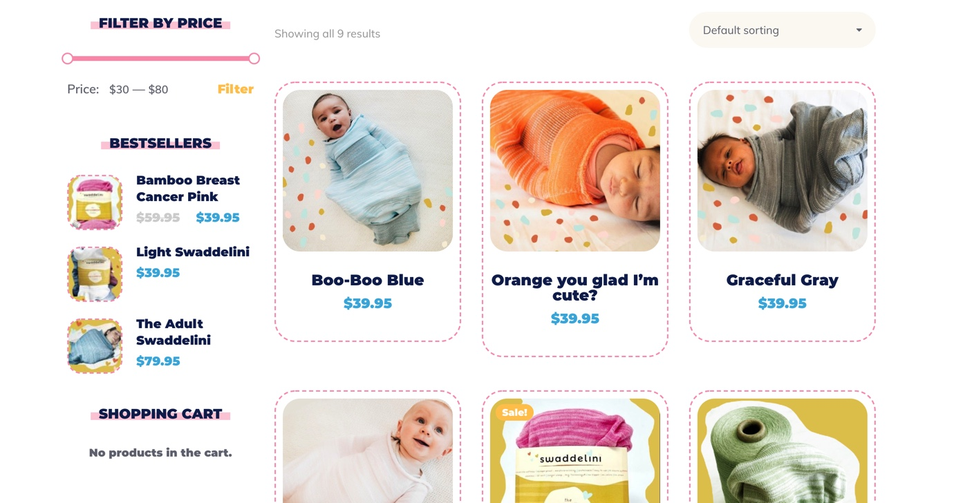

Main Content
On this page there is no main content at the top of the page, only a small bit in the footer with minimal information on the technology used and products offered. Using the keyword, I would write an introduction to the product, talk about the technology used, and point out what variations of the product are offered. This would be placed at the top of the page underneath the Header 1 “Shop”. The paragraph would be:

‘Shop the Swaddelini! The Swaddelini is a unique baby sack product new to the world of parenting. The product is the world’s first 3D knit swaddle that uses Hug Technology® to optimize the comfort your baby feels while in the baby sack. The product is available in a variety of colors and sizes to make sure your baby is cute, comfortable, and calm. It now comes in adult sizes too!’

I would also put in paragraphs about the design of the product and the Hug Technology® that the owner has patented. These paragraphs would be right after the introduction, but underneath a “Read More” dropdown:

‘The Swaddelini baby sack is the only one of its kind. But how? It is engineered with arm tubes to protect against moro reflex, face scratching, and has Hug Technology® built into the chest area to give the sensation of a hug all night long. There is an easy access diaper opening at the bottom so the feet stay warm but it still provides easy diaper changing access so there is no need to take the swaddle off during the night.

What is Hug Technology®? The Hug Technology® feature was inspired by Hilton’s work creating compression garments for children with lymphedema and cerebral palsy. The compression imitates the comfort of a hug and help to calm your baby and keep them asleep longer.

What types of Swaddelini are there? There are two different tiers of the Swaddelini baby sack. The Swaddelini Original is made with a moisture wicking synthetic blend while the Swaddelini Bamboo-37.5 is made from bamboo and a proprietary fiber which helps regulate body temperature in the microclimate. These variations allow for you to pick the best baby sack for your child’s needs.

Is swaddling safe? Yes! Our Swaddelini baby sacks have gone through testing done by world class textile safety laboratories. These safety testing, which included factors like suffocation and flammability, went on for over a year before the product was launched. The Swaddelini has won multiple innovation awards, making it one of the best baby sacks on the market.’

With this addition to the Shop page and the bit that is already in the footer, the main description would be fully optimized for SEO and give customers a better idea of what they are buying.

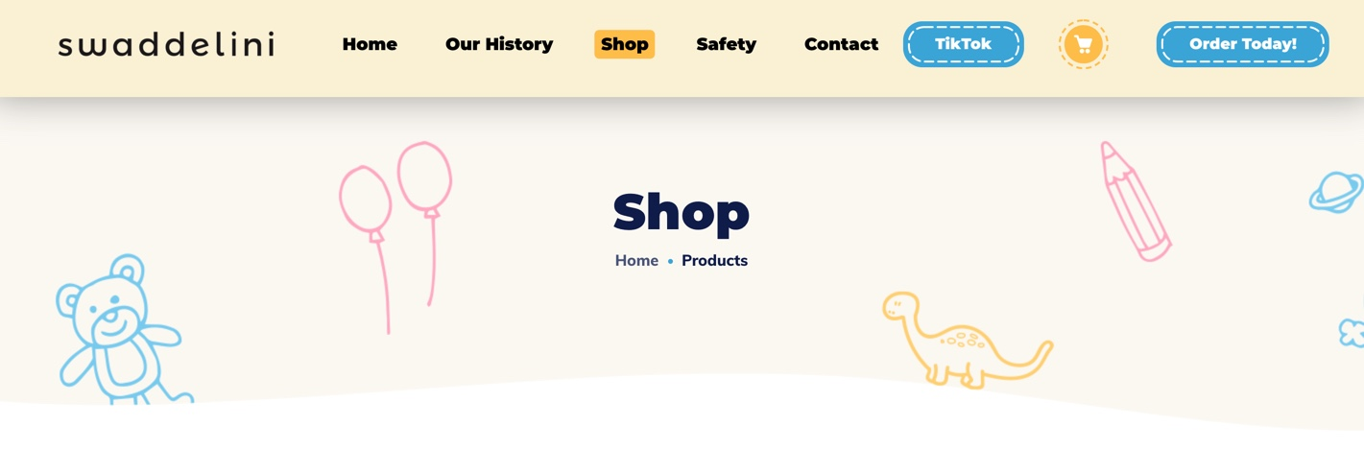

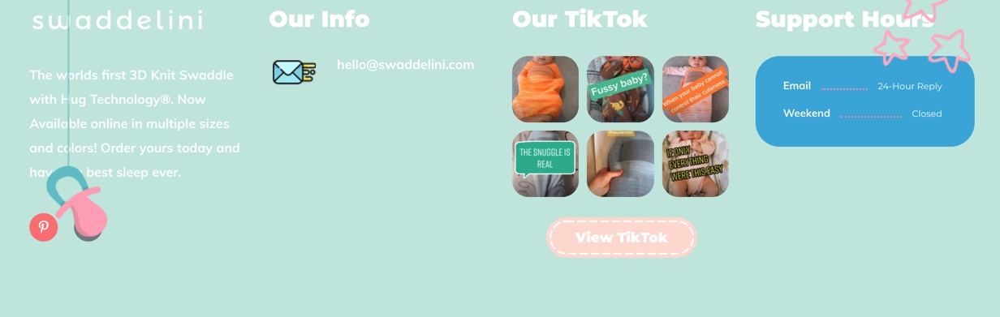

Image ALT Text
All the images used on the page are for products. Each product has two pictures; the one you see when you first click on the landing page, and the one you see when you hover over the product. All 9 products, 18 photos, have the image ALT text “lazy”. Below is what I believe they should be:

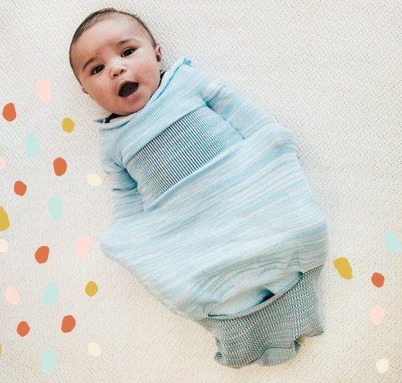 | 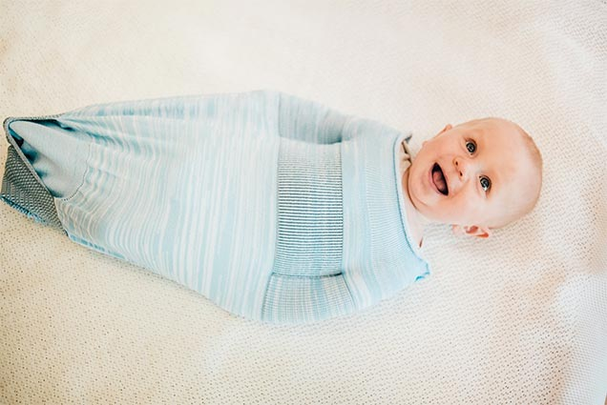
Boo boo blue baby sack | Boo boo blue baby sack laughing baby
 | 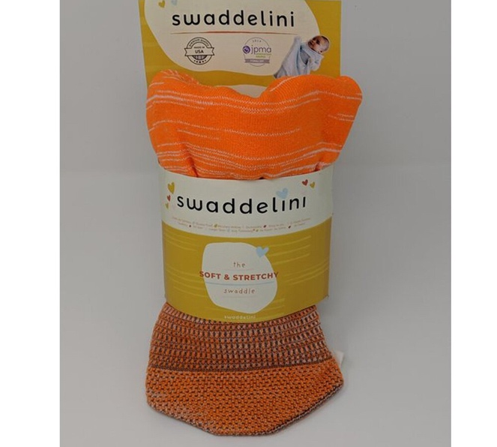
Orange you glad baby sack sleeping baby | Orange you glad baby sack packaging
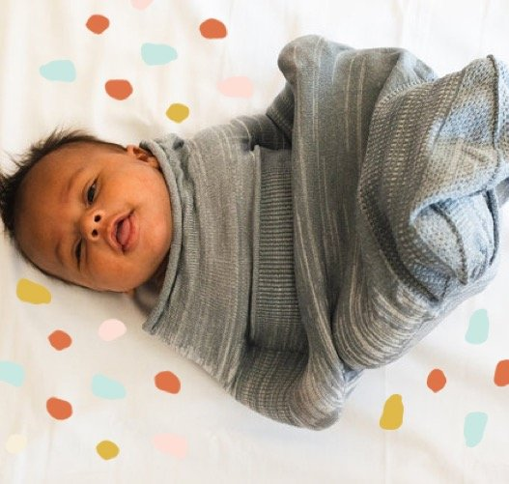 | 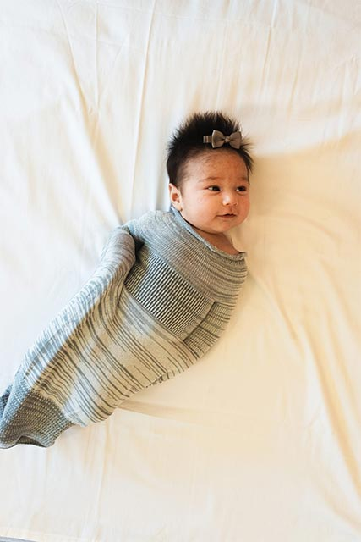
Graceful gray baby sack | Graceful gray baby sack baby with bow
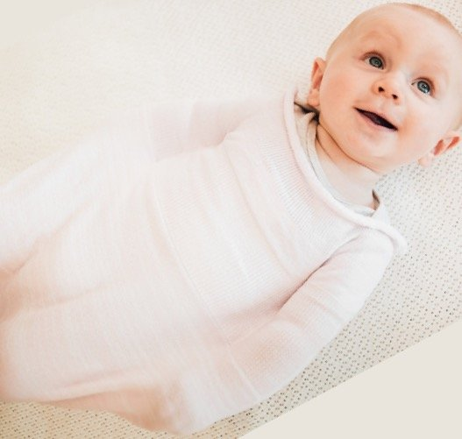 | 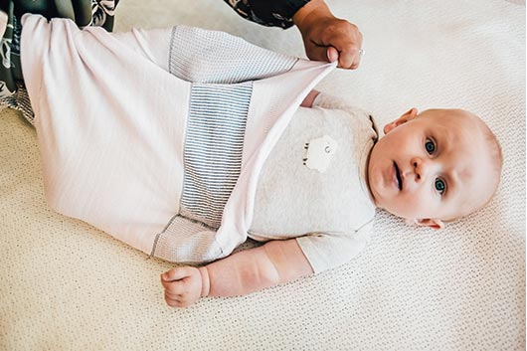
Peaceful pink baby sack smiling baby | Peaceful pink baby sack being put on baby
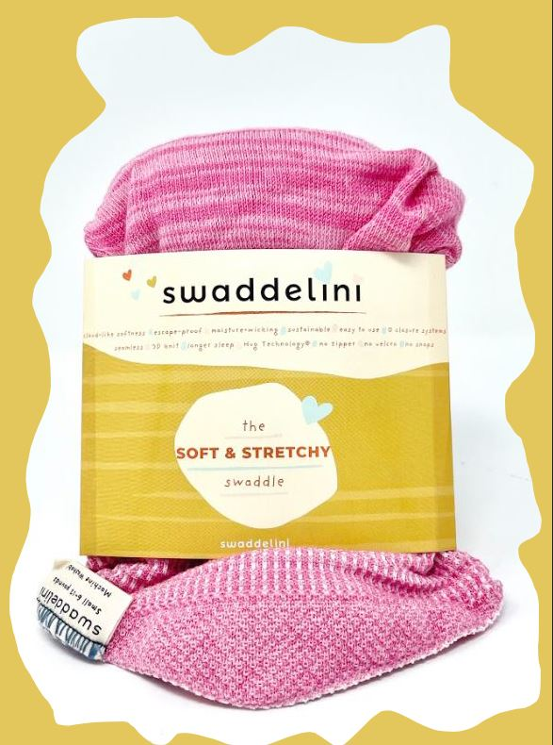 | 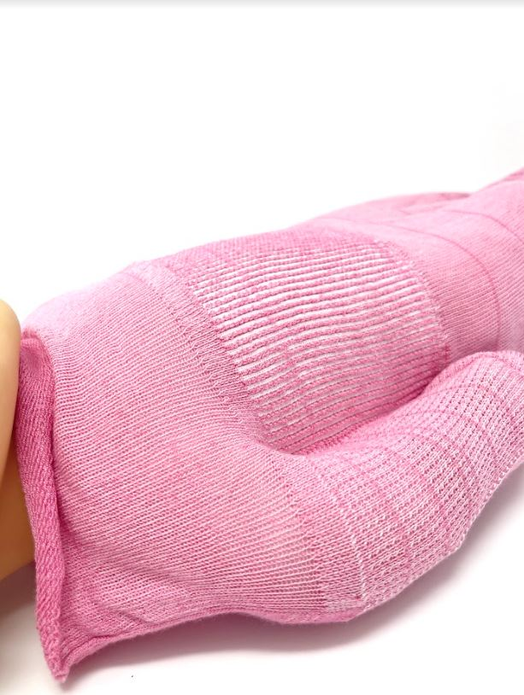
Bamboo breast cancer pink baby sack packaging | Bamboo breast cancer pink baby sack
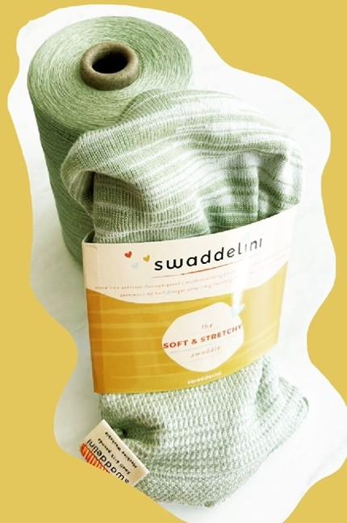 | 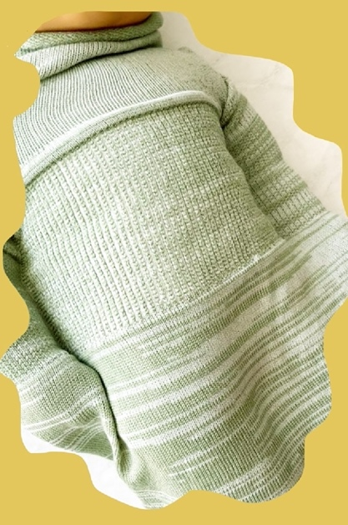
Bamboo millennial mint baby sack packaging | Bamboo millennial mint baby sack
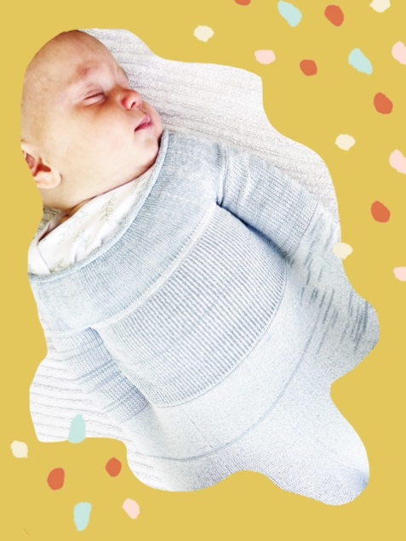 | 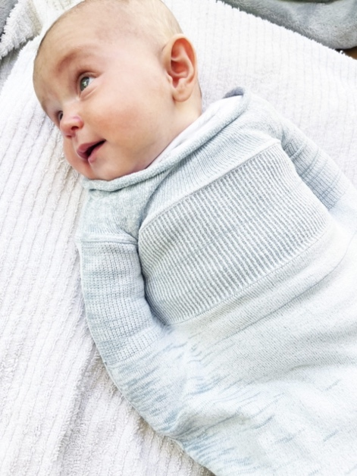
Raindrop baby sack baby with eyes closed | Raindrop baby sack baby with eyes open
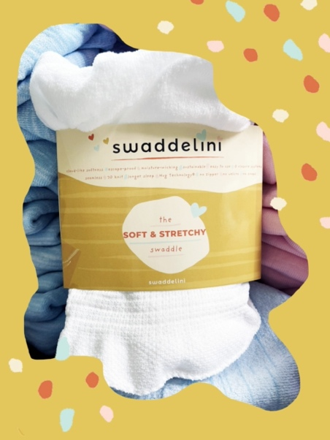 | 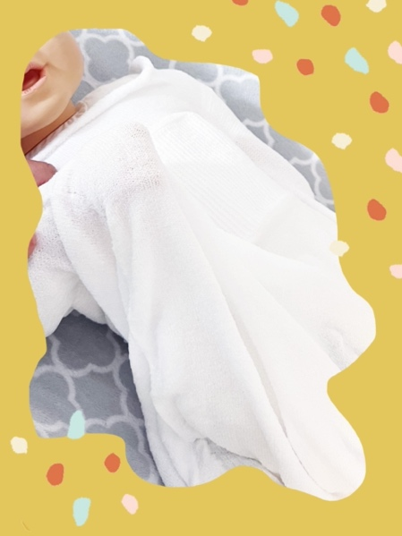
Light swaddelini baby sack packaging | Light swaddelini baby sack
 | 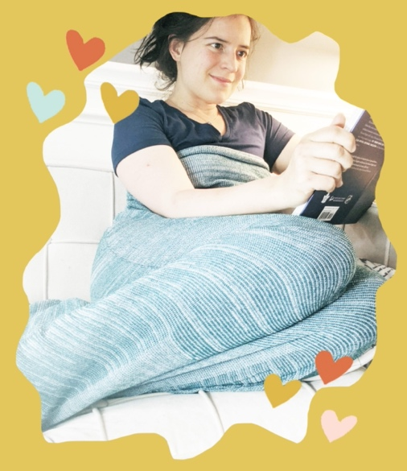
Adult swaddelini baby sack sleeping | Adult swaddelini baby sack reading

Anchor Text
Aside from the main menu, there are buttons that link to the Swaddelini TikTok account and shopping cart. Since it is the shop page, there are also links under all the product names and pictures that lead to the individual product pages, as well as a shopping cart button that pops up when you hover on the product which leads to the product page as well. This gives the buyer the easiest navigation possible when trying to buy a product. Something else the page has is “breadcrumbs” which are placed under the Shop title and follow your progress through the shop. For example, when on the shop page it reads ‘Home . Products’ and on a product it will read ‘Home . Swaddles . Product Name’. The breadcrumbs link back to the pages you’ve previously visited and allow for an easy click back to them. Something I would look at is the wording used. From what I can tell, the shop page will say “products”, but there is also a “swaddle” page. Both pages have the same layout since the only thing the company sells is swaddles. I think it is extra work to have both, and I recommend taking it down to only the shop page. I would use the key phrase and instead of “products” have it read “baby sacks”.

In my suggested main content, I argue that there should be a section on the making of the product and the Hug Technology® used. I believe there should be an anchor text linking back to the Safety page for customers to learn more about the development and safety features of the product. I would link this to the sentence “Is swaddling safe?” to give users a straight shot to the Safety page to learn more.

In the footer there is another link to the TikTok page as well as a link to email the company if needed. There is also a button leading to Pinterest, however it is not linked to anything. This could be that the owner is in the process of making the page, or they forgot to connect the link. Either way, I recommend getting that added.

Meta Description
Shop the Swaddelini, the best baby sack on the market for swaddling your baby. The world’s first 3D knit swaddle uses Hug Technology for optimal comfort.

Conclusion
The focus of the Shop page should be around the new keyword phrase “baby sack” due to the large rising trend around the phrase. The areas where this will be heavily implemented are the header titles, main content, and image ALT texts. These aspects of the website will have the keyword phrase implemented multiple times to increase the use and awareness of the phrase. There should also be implementation in the title tag, URL, and meta description to directly affect the page’s SEO. The phrase “baby sack” gives the page its best chance of being recognized by Google and SEO metrics, which will bring in more consumers and hopefully more sales for the company.

